**Predictive Maintenance for Production Equipment - Entertainment Sector**

Pooja Joshi & E.Code [E25007]

# Overview :

# Predictive maintenance involves using data analysis to predict when equipment will fail, allowing for timely interventions to prevent downtime. This project focuses on implementing predictive maintenance strategies for production equipment in the entertainment sector, utilizing sensor data to forecast failures and optimize operational efficiency.

# Objective:

The main goals include preprocessing sensor data, implementing a Random Forest model for failure prediction, and visualizing the analysis results.

# Assigned Task(s) :

· Data preprocessing and cleaning.

· Feature engineering and transformation.

· Model training and evaluation using Random Forest.

# Task Details :

· **Task 1: Data Preprocessing**

* · **Status:** Completed
* **Details:** Cleaned the dataset by handling missing values and normalizing sensor data.

· **Task 2: Feature Engineering**

* · **Status:** In Progress
* **Details:** Created new features, including rolling averages and lag features to enhance model performance.

**Task 4: Visualizations**

· **Status:** In Progress

· **Details:** Generated visualizations to explore sensor data distributions and relationships. Below are some key visualizations created:

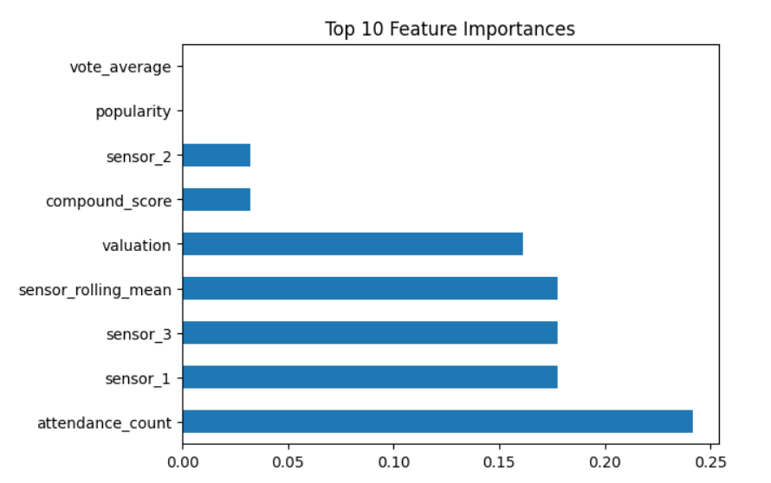

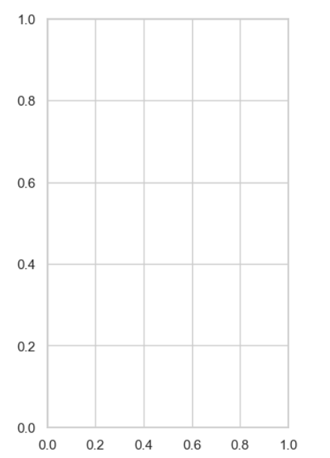

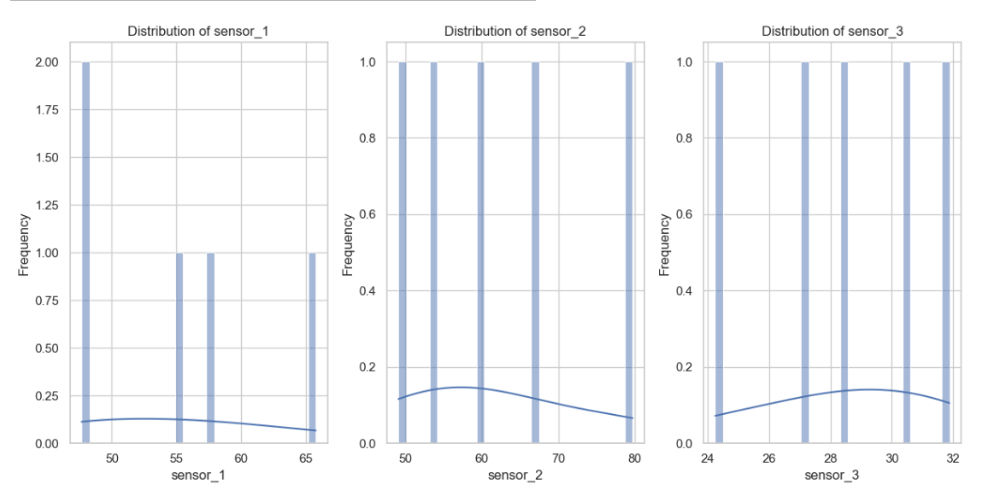

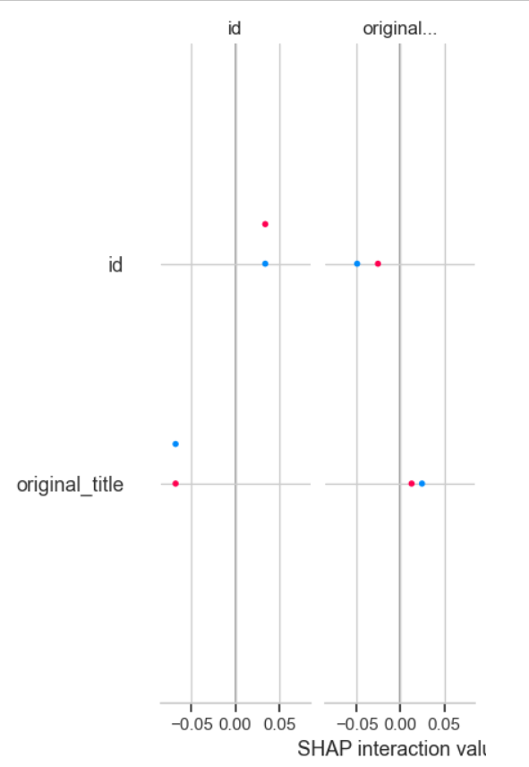

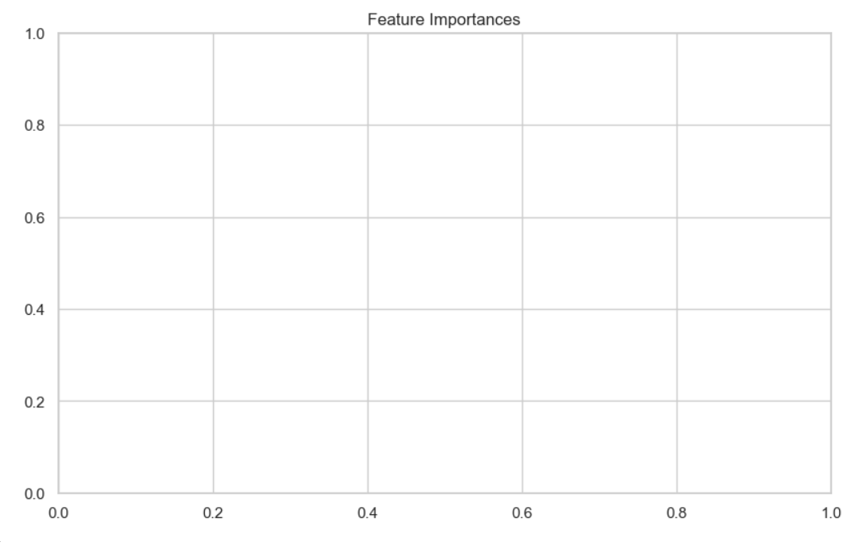

**Progress :**

· **Accomplishments:**  
  
Successfully cleaned and prepared the dataset for modeling, with key features identified for further analysis.

· **Metrics:**  
The dataset contains 1,000 samples with a balanced distribution of failure and non-failure cases, ensuring robustness in model training.

# Challenges and Solutions :

· **Challenges Faced:**  
Encountered issues with missing values and the need for feature normalization to improve model accuracy.

· **Solutions Implemented:**  
Utilized imputation techniques for missing values and applied Min-Max scaling for feature normalization.

**Next Steps :**

* **Upcoming Tasks:**

1. Complete feature engineering and finalize the dataset.
2. Train the Random Forest model and conduct hyperparameter tuning.

* **Goals:**  
  Aim to achieve a model accuracy of over 85% and establish baseline metrics for future comparisons.

# Conclusion :

### Summary:

### In summary, significant progress has been made in preparing the data for predictive maintenance analysis. The next steps will focus on model training and evaluation.

# **Acknowledgments**: Thank the audience for their time and attention.